**Regulatory Compliance in Banking**

It's the adherence to a set of rules and practices set by regulatory bodies. These rules aim to:

**Maintain Financial Stability:** By ensuring banks have enough capital (funds) to withstand economic downturns and avoid financial crises.

**Protect Customers:** Safeguarding information privacy (think Gramm-Leach-Bliley Act) and preventing fraud.

**Promote Ethical Conduct:** Ensuring fair lending practices and preventing money laundering.

**The Cost Of Compliance**

Since 2009, regulatory fees have increased dramatically relative to banks earnings and credit losses.

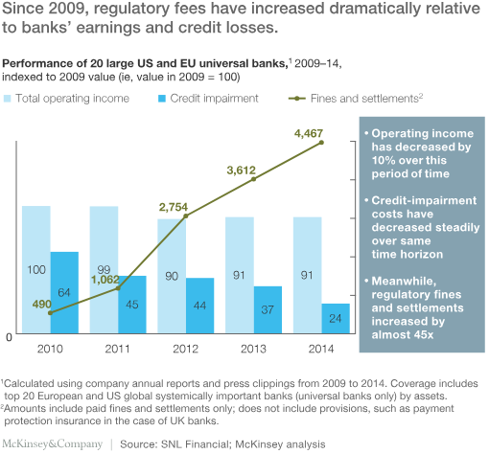

* Operating income has decreased by 10% over this period.
* Credit-impairment costs have decreased steadily over same period.
* Meanwhile, regulatory fines and settlements increased by almost 45x

Limited Scope: Designed as an enforcement arm, the compliance function focused on issuing regulations and internal policies in an advisory role. It lacked a strong focus on actively identifying and managing actual risks.

Disconnected from Business: This approach resulted in a limited understanding of the bank's operations, underlying risk exposures, and how regulations translated into practical actions for management.

Focus on Testing, not Risk: Even with compliance testing programs, the emphasis was on bottom-up, subjective control testing, resembling an outdated operational risk approach. This was less Burdensome Compliance: Business managers were often left to figure out specific controls for regulations, leading to a build-up of labour-intensive activities with questionable effectiveness.

Many banks still struggle with fundamental control environment issues in core operations. This includes employee compliance knowledge, accountability, performance incentives, and overall risk culture.

Isolated Function: Compliance activities often existed in isolation, lacking a clear connection to the broader risk management framework, governance, and processes (e.g., operational risk management, risk appetite statements, and risk reporting).

**Customer relationship management (CRM) in banking**

CRM helps banks improve customer retention and drive revenue growth by increasing customer satisfaction and enabling personalized service. It provides banks with better insights into customer behavior and preferences, allowing them to offer tailored products and services.

CRM enhances the overall customer experience by facilitating better communication and understanding between the bank and its clients. It enables banks to identify new business opportunities with existing and potential customers, thereby generating more revenue.

CRM helps banks streamline processes, improve employee productivity, and make data-driven decisions by consolidating customer information in a centralized system. This allows bank staff to quickly access a complete view of each customer's profile and history, leading to more efficient and personalized interactions.

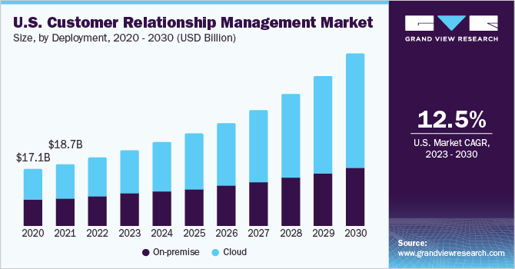

The overall U.S. CRM market is expected to experience significant growth, reaching $30.6 billion by 2030. This indicates a growing importance of customer relationship management in the United States.

Shift Towards Cloud-Based CRM:

The graph highlights a significant shift towards cloud-based CRM solutions. The green line representing cloud CRM shows a steeper incline compared to the blue line for on-premise CRM, indicating a preference for cloud-based solutions.

On-premises CRM Decline:

The blue line suggests a decline in the market share of on-premise CRM solutions. While some businesses may still prefer on-premise solutions for reasons like data security or customization, the advantages of cloud-based CRM are becoming increasingly attractive.

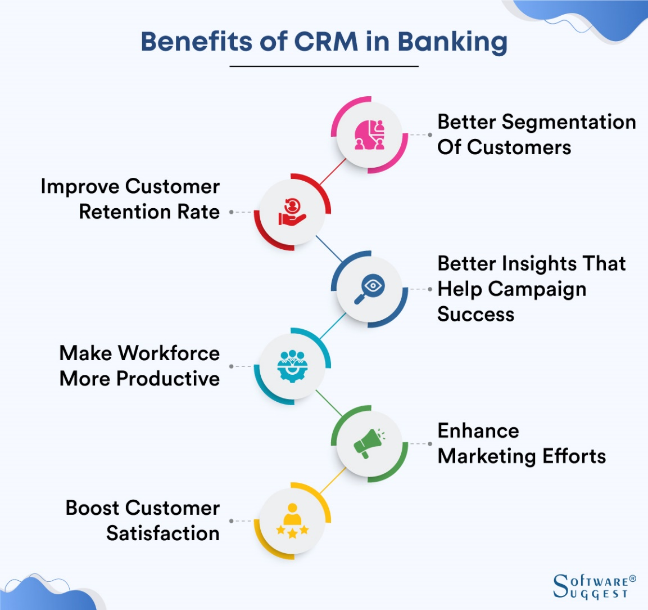

CRM plays a critical role in the success of modern US banking. By leveraging a CRM system that addresses US-specific needs and regulations, banks can gain a competitive edge by providing a personalized, compliant, and efficient customer experience.